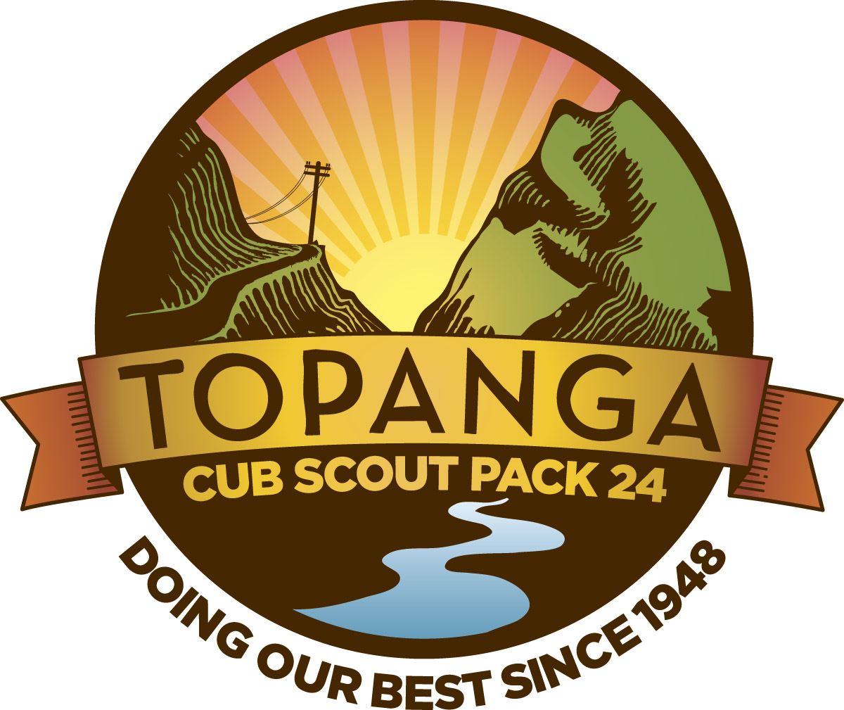

TOPANGA CUB SCOUT PACK 24
PACK MEETING AGENDA
March 3, 2011, 6:30 p.m.
Sholty Residence

Gathering
Sign-in/attendance: have PARENTS pick up Pinewood Derby Kits; tell parents to check website for sites with tips; review rules and note they will be posted on the website
Freeze tag (see attached pages) or toilet tag redux

Flag Ceremony

Webelos will do special ceremony

Program

1. Welcome from Cubmaster

(a) The Core Value we will discuss tonight is a positive attitude: being cheerful and setting our minds to look for and find the best in all situations. Through participating in the Raingutter Regatta, Scouts should see the importance of having a positive attitude, regardless of the outcome of the race.

(b) Henry Ford story:

Henry Ford is certainly an example of positive attitude. He built his first vehicle, called the Quadricycle, in 1896, and with two other investors founded the Detroit Automobile Company in 1899. But that company failed and went out of business in 1900. But he didn’t give up. He started the Henry Ford Motor Company in 1901 with five other investors. But after four months he was forced out of that company, but he kept his tools and rights to use his name. So in 1903, he tried again. He started the Ford Motor Company and continued to work on new models and techniques, even visiting other countries to see their methods even though he was just starting out again. In 1909, he finally produced the Model T -- a basic, sturdy, inexpensive car that was reliable and available to the ordinary family. But despite some success, he pushed harder, and introduced the moving assembly line in 1913. By 1925, his Model T was a huge success. He had set himself the goal to produce a basic, sturdy, reliable vehicle, and despite the failure of his first two companies he kept his positive attitude, learned from his mistakes and met his goal.

(c) Discuss t-shirts and “B” uniforms again (bring shirts)

(d) Discuss drift box--bring items found on outings to next Pack meeting

(e) Mention that we have another set of membership cards including some for those who joined recently

Finish with pat on the back cheer

. 2. Announcements:

(a) Emerald Bay family camp (March 25-27) -- 36 people signed up. Pack Registration is closed. However, we can still probably find space for you if you sign up now online -- let me know if you want to do this and I will ask Shawn to combine your registration with our Pack Registration.
(c) Rescheduling night hike--March 20? Not full moon but close
(d) New President of the Community Club, Mark Nygard; booth at Topanga Days for selling soda; mention Council has approved.

Need volunteers:

-- someone to spearhead float
-- someone to spearhead tracking down info re Cub Scout we want to honor
-- someone to spearhead having Scouts participate in flag ceremony
-- people to help with booth
-- people to help me make soda

(e) Updates from each Den leader re upcoming Den meetings; discuss Outdoor Achievement Award we are all working on as a Pack and as Dens. Explain purpose: progressively build and recognize outdoor experiences to prep Scouts for more and more advanced activities in the outdoors that are designed to make them comfortable and skilled in outdoor activities

(f) April 3 Pinewood Derby Build Day; April 10 race day; will do Raingutter in Fall going forward

On build day note, finish with carpenter cheer (bang bang OUCH)

4. Skit: Wolves/Bears

Finish with electrician cheer (A/C D/C BAAAAAA!)

5. Audience Participation: Climb A Mountain

6. Song (KennyMazur)

Finish with mosquito cheer

7. Game: Steal the Bacon (prepare awards while game is in progress)

Recognition/Advancement

Present Raingutter Regatta awards

Discuss Centennial Quality Unit Award

Cubmaster’s Minute

Give thanks for everything everyone has done in the last two months

Closing

Retire colors

S’mores/free time
* * *

Gathering Activity: Freeze Tag

Freeze tag
When a player is tagged, he doesn't become it, but must hold one of his hands in the place where he was tagged on his body, and continues playing. The second time a person is tagged, he must hold his other hand where he was tagged for the second time, while still holding his hand in the first place he was tagged. The third time he is tagged, he becomes 'it'. One variant involves the rule that if a player is tagged he is still not 'it' but must stay frozen in place. If an untagged player touches a frozen person, the person is back in. This form of the game is long, lasting until the person who is 'it' gives up, or everybody is frozen. A third variation of this game is called ambulance tag. It is similar, but when tagged for the third time, a player must go to a predetermined spot known as a hospital. Players must count to either 3 or 5 before rejoining the game.

Audience Participation: Let's Climb a Mountain
The leader says "Want to climb a mountain? Then just say what I say and do what I do. All set? Let's go!
"I think I'll climb a mountain." (Audience repeats this and following phrases.)
"Let's pack." (Put imaginary things into imaginary pack and throw over shoulder).
"Out the door!" (Single clap to indicate banging of door.)
"Down the street!" (Marching claps with both hands against thighs).
"Awfully big town." (Continue marching.)
"In the country at last! (Speed up march.) Here's a river." (Continue marching.)
"And here's a bridge." (Resume ordinary marching.) "Let's cut across." (Swish palms together.)
"Here we are at the foot of the mountain. Let's start climbing." (Clap thighs more slowly.)
"Lost!" (Several slow marching stops and starts.)
"There's a tree, let's climb it and look around." (Fast clapping to indicate running to tree, then arm motions for climbing. Then hand to forehead and peer in several directions.)
"Still lost." (Make slow climb down the tree, then several hesitant marching starts and stops.)
"Look, there's a cave!" (Fast clapping for run to cave.)
"This side is cold." (Feel with hand against imaginary side.)
"This side is wet." (Feel other side.)
"There's a light!" (Point with one finger into cave.)
"There's another light!" (Point in same direction.)
"They're eyes! It's a bear!" (Rapidly reverse actions: coming down mountain, jumping stream, swishing palms across field, over bridge, through streets, ending with a loud clap for door closing back home.)
"Back home! Safe at last! But wasn't that a great climb?"

Game: Steal the Bacon
- Divide the troop into two halves (not three halves, nor one half). Number off EACH half separately. If there are 30 boys in the troop, then you would have two groups, each numbered from 1-15. Line them up facing each other, about 30-40 feet apart. In numerical order. Place your 'bacon' between the lines at X. Now the field will look like this:
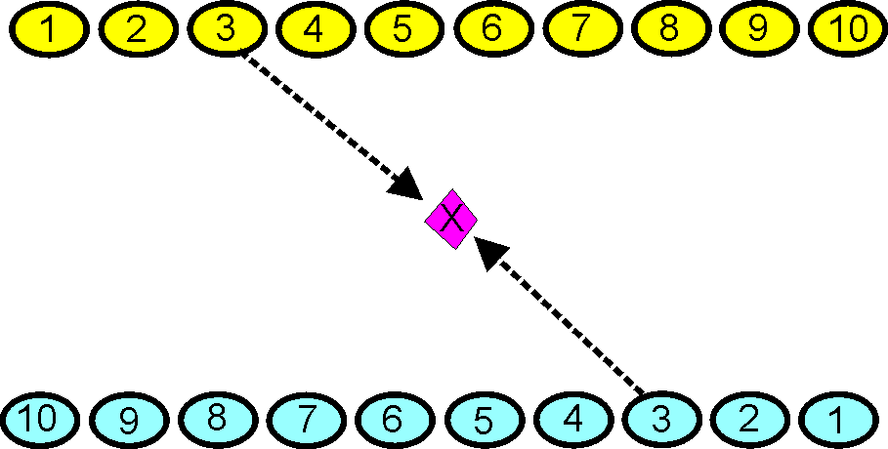
The idea is for a scout to go out and retrieve the object. The leader calls out a number, and each scout with that number runs out and tries to get the object and go back behind his line.
Once the object is touched, the scout that touched the object can be tagged by the other scout. There are two ways to win a round: Either get the object and bring it behind your line without being tagged, or tag the other scout after he grabs the object and before he makes it past his line.
Outdoor Activity Award Requirements

This Award is meant for Cub Scouts.
Decide for yourself if it is appropriate for your younger scouts or not.
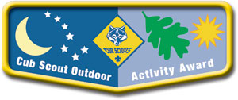
Cub Scouts at all levels from Tiger to Webelos can earn the Outdoor Activity Award. When the award is first earned, the scout receives the pocket flap award, worn on the right pocket flap of his uniform. In each additional year that he earns the award, a wolf track pin is attached to the flap. The Summertime Pack Award pin should be pinned through this patch just like the wolf track pins.
Successive years should build on skills and experiences from earlier years, having the scouts participate in more extensive activities.
Requirements:
Scouts at all ranks must attend Cub Scout day camp or Cub Scout/Webelos Scout resident camp in the current program year.
Tiger Cubs
Complete one requirement in Achievement 5, 'Let's Go Outdoors' (Tiger Cub Handbook) and complete three of the outdoor activities listed below.
Wolf Cub Scouts
Assemble the 'Six Essentials for Going Outdoors' (Wolf Handbook, Elective 23b) and discuss their purpose, and complete four of the outdoor activities listed below.
Bear Cub Scouts
Earn the Cub Scout Leave No Trace Award (Bear Handbook, Elective 25h) and complete five of the outdoor activities listed below.
Webelos Scouts
Earn the Outdoorsman Activity Badge (Webelos Handbook) and complete six of the outdoor activities listed below.
Outdoor Activities:
With your den, pack, or family:
- Participate in a nature hike in your local area. This can be on an organized, marked trail, or just a hike to observe nature in your area.
- Participate in an outdoor activity such as a picnic or park fun day.
- Explain the buddy system and tell what to do if lost. Explain the importance of cooperation.
- Attend a pack overnighter. Be responsible by being prepared for the event.
- Complete an outdoor service project in your community.
- Complete a nature/conservation project in your area. This project should involve improving, beautifying, or supporting natural habitats. Discuss how this project helped you to respect nature.
- Earn the Summertime Pack Award.
- Participate in a nature observation activity. Describe or illustrate and display your observations at a den or pack meeting.
- Participate in an outdoor aquatic activity. This can be an organized swim meet or just a den or pack swim.
- Participate in an outdoor campfire program. Perform in a skit, sing a song, or take part in a ceremony.
- Participate in an outdoor sporting event.
- Participate in an outdoor Scout's Own or other worship service.
- Explore a local city, county, state, or national park. Discuss with your den how a good citizen obeys the park rules.

