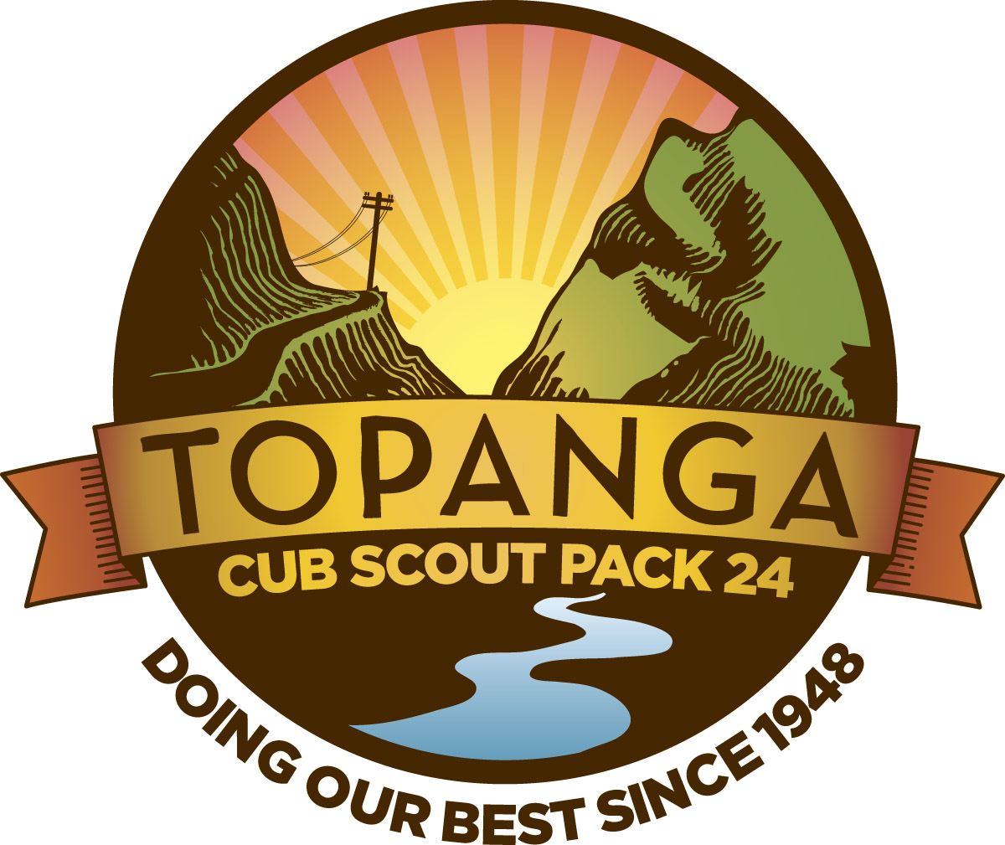

TOPANGA CUB SCOUT PACK 24
BLUE AND GOLD BANQUET
June 16, 2011, 6:15 p.m.
Community House

Gathering
Sign-in/attendance: find volunteer.
Hat tag or toilet tag redux

Flag Ceremony

Greg Kubler to run.

Program

1. Welcome from Cubmaster

(a) Thanks for the opportunity to serve as your Cubmaster

Honor and privilege

Come a long way in six months, been quite an adventure

Why do I do this? I do this for the moments when I see a cub’s face light up the first time they sit at a campfire and have s’mores.

I do this for the words Janet Pedersen whispered in my ear after the flag ceremony at Topanga Days when she said “I will remember your Pack and this Day the rest of my life.”

And of course I do this most of all for my wonderful son, so he may experience all Cub scouting has to offer.

Show slide show

(b) Back to what cub scouting has to offer

Not just a camping club

Not just about belt loops

It is about achievement by advancement through ranks. What does that mean? It means completing the requirements for each rank which are designed to teach core values that go far beyond camping skills – cooperation, citizenship, a positive attitude, faith, health and fitness, perserverance, and courage. We will be focusing on those core values in Pack meetings even more during the coming year but they are already woven into the requirements for each rank.

But to me, above all, achieving the many tasks needed to earn each rank teach our cubs about never giving up. And I have a very short story to illustrate that principle.

Way back in the 1968 Olympics, Bob Beamon set a longjump record that many thought would never be broken, but eventually it was. A young boxer named George Foremen won a gold medal and paraded around the ring with an American flag, instilling pride in many Americans. But, one athlete named John Stephen Akhwari from Tanzania, a marathon runner, probably made the longest lasting impression on people during those Olympics.
While he was running his race, he stumbled and fell, severely injuring his knee and ankle. After receiving first aid, he did what no one expected and he got back in the race. Long after everyone else had finished and left, he limped into the near empty stadium to the cheers of a small crowd that was still there and he finished his final lap.
When asked why he continued the race after he was so badly hurt with no chance to win he replied: "My country did not send me 7,000 miles to begin a race - they sent me to finish the race".
Do each of you accept responsibility to finish a task when you start one or do you take the easy way out when the going gets tough? Do you keep your promises when you make them, even the ones you make to yourself? A man who doesn't keep his word will not be respected and will not be trusted. What kind of man does each of you want to be remembered as?

. (c) What are the goals of advancement?

We are here tonight to honor Cub Scouts who have advanced in rank since we last met as a Pack. As he walks the achievement trail, the Cub Scout achieves many goals.

First comes the Bobcat, the beginner. He learns the Cub Scout motto – and what is that? Do your best! The Cub Scout Promise, and the law of the Pack.

Will all Scouts stand at attention please. Repeat the Cub Scout Promise:

I, [say your name], promise to do my best, to do my duty, to God and my country, to help other people, and to obey the law of the Pack.

Repeat after me the Law of the Pack:

The Cub Scout follows Akela. The Cub Scout helps the Pack go. The pack helps the Cub Scout grow. The Cub Scout gives goodwill.

You may be seated.

These principles we just reviewed guide the advancement trail. And without advancement, there is no Cub Scout program.

Now a word first about belt loops. We will be giving out belt loops tonight to get everyone caught up. Ordinarily those are supposed to be handed out by den leaders in den meetings as soon as possible after they are earned. For example as Tigers we gave out 85 belt loops during a recent den meeting, and I love to see that because it means cubs and parents are excited about earning the belt loops. But this process all starts with you as parents – we can’t award them unless we know your scouts have earned them. So you have to let us know. And we will be focusing on making sure all scouts in our Pack get their belt loops and pins in a timely fashion during the coming year.

But while belt loops are great, they are not a substitute for advancement through ranks, which are designed to impart the core values of scouting. And such advancement will be a focus going forward too.

We talked earlier about the Bobcat. As he climbs this trail, he grows in knowledge, skills, and fun.

Tigers

Next comes the Tiger Cub. He completes five achievements each in three areas: family, den and go see its. He has learned about the outdoors, where he lives, and health and safety.

So very proud of our Tiger Cubs, including my son Gram. All 12 active Tigers have advanced, which is fantastic. I couldn’t be happier.

Will the following Tiger Cubs and their parents please come forward. Tiger Cubs to stand in a line, with their parents behind them.

Trey Buck
Sam Vincent Cahill
Flynn Aubrey Colgin
James Jason Dean
Harrison Denman
Baedan Michael Fancher
Spencer Andre Foote
Daniel Kenneth Kubler
Lucas William Lombardo
Gram Theodore Nylen
Kyle Wright
Miles Zaud

You have worked hard all year to complete all of the achievements for the Tiger rank. Many of you have also earned belt loops and even pins, gone on Pack campouts and outings, helped with our parade and float and booth and gift drive for the shelter for homeless families, and many other things. But we are here tonight to honor your achievement in advancing to the Wolf rank, technically the first Cub Scout rank.

Parents, please remove your cubs’ Tiger hats and neckerchieves. I urge you to donate them to the Pack in the drift box for our incoming Tigers.

Please advance to pick up your cubs’ new Wolf hat, neckerchief and Wolf Cub book and put the new scarf and hat on your cub. While I am doing that, please pin the badge on your scout with the provided pin, and make sure the badge is upside down—needs to remain that way until they do a good turn. Then sew it on. If you lose it, we have provided a card you can take to the Scout store to obtain a new badge.

Scout handshake to all

I will also now present the Outdoor Activity Award to all Tiger Cubs, who completed the following:

Attended Cub Scout day camp or resident camp at Emerald Bay, and:
Complete one requirement in Achievement 5, 'Let's Go Outdoors' (Tiger Cub Handbook) and: completed three of the outdoor activities listed below. with your den, pack, or family:

Participate in a nature hike in your local area. This can be on an organized, marked trail, or just a hike to observe nature in your area.

Participate in an outdoor activity such as a picnic or park fun day.

Explain the buddy system and tell what to do if lost. Explain the importance of cooperation.

NOTE: tell people it goes on the right shirt pocket.

I will also present to the Tiger cubs now any additional belt loops they have earned.

Finish with mosquito cheer and round of applause

Turn over to Ron for Wolves and Bears.

Then give belt loops and pins to Viswa Douglass of the Bears and Stephan Tso of the Webelos

5. Song (KennyMazur and Greg Nylen)

Two Minutes for Tom

Cubmaster’s Minute

Give thanks for everything everyone has done in the last six months, (Tom for everything he has done as Pack Committee Chair and otherwise, Andy for all he has done as Advancement Chair, our Den leaders Ron Fomalont and Jim Sholty, Charles Nance, Kenny Mazur and Susan Clark and everyone else who helped with the float and flag ceremony at Topanga days, everyone who volunteered time at our booth at Topanga Days, to Greg Kubler and Ken Fancher for putting this evening together and to Ken for stepping up as Assistant Scoutmaster, and of course most of all to me personally thank Mary Ann for all she has done as Outings Chair, Assistant Tiger Den Leader and general amazing person.

Stress volunteers needed, however -- we will be calling on you in that regard shortly.

Leave with a quote from one of my favorite historical figures, Mark Twain, about my philosophy with this Pack going forward:

Twenty years from now, you will be more disappointed by the things that you didn't do than by the ones you did do.
So throw off the bowlines.
Sail away from the safe harbor.
Catch the trade winds in your sails.
Explore.
Dream.
Discover!
Mark Twain penned those words years ago and they are still valid today. Be prepared and take advntage of all the opportunities that come your way.

Closing

Retire colors

* * *

Gathering Activity: Freeze Tag

Freeze tag
When a player is tagged, he doesn't become it, but must hold one of his hands in the place where he was tagged on his body, and continues playing. The second time a person is tagged, he must hold his other hand where he was tagged for the second time, while still holding his hand in the first place he was tagged. The third time he is tagged, he becomes 'it'. One variant involves the rule that if a player is tagged he is still not 'it' but must stay frozen in place. If an untagged player touches a frozen person, the person is back in. This form of the game is long, lasting until the person who is 'it' gives up, or everybody is frozen. A third variation of this game is called ambulance tag. It is similar, but when tagged for the third time, a player must go to a predetermined spot known as a hospital. Players must count to either 3 or 5 before rejoining the game.

Audience Participation: Let's Climb a Mountain
The leader says "Want to climb a mountain? Then just say what I say and do what I do. All set? Let's go!
"I think I'll climb a mountain." (Audience repeats this and following phrases.)
"Let's pack." (Put imaginary things into imaginary pack and throw over shoulder).
"Out the door!" (Single clap to indicate banging of door.)
"Down the street!" (Marching claps with both hands against thighs).
"Awfully big town." (Continue marching.)
"In the country at last! (Speed up march.) Here's a river." (Continue marching.)
"And here's a bridge." (Resume ordinary marching.) "Let's cut across." (Swish palms together.)
"Here we are at the foot of the mountain. Let's start climbing." (Clap thighs more slowly.)
"Lost!" (Several slow marching stops and starts.)
"There's a tree, let's climb it and look around." (Fast clapping to indicate running to tree, then arm motions for climbing. Then hand to forehead and peer in several directions.)
"Still lost." (Make slow climb down the tree, then several hesitant marching starts and stops.)
"Look, there's a cave!" (Fast clapping for run to cave.)
"This side is cold." (Feel with hand against imaginary side.)
"This side is wet." (Feel other side.)
"There's a light!" (Point with one finger into cave.)
"There's another light!" (Point in same direction.)
"They're eyes! It's a bear!" (Rapidly reverse actions: coming down mountain, jumping stream, swishing palms across field, over bridge, through streets, ending with a loud clap for door closing back home.)
"Back home! Safe at last! But wasn't that a great climb?"

Game: Steal the Bacon
- Divide the troop into two halves (not three halves, nor one half). Number off EACH half separately. If there are 30 boys in the troop, then you would have two groups, each numbered from 1-15. Line them up facing each other, about 30-40 feet apart. In numerical order. Place your 'bacon' between the lines at X. Now the field will look like this:
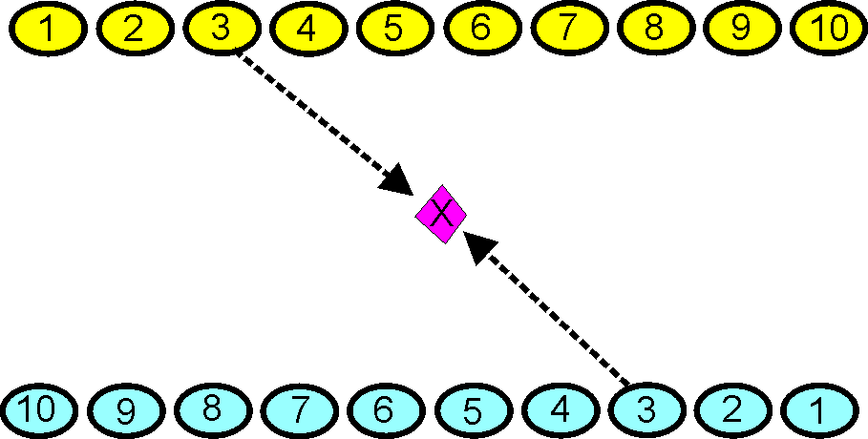
The idea is for a scout to go out and retrieve the object. The leader calls out a number, and each scout with that number runs out and tries to get the object and go back behind his line.
Once the object is touched, the scout that touched the object can be tagged by the other scout. There are two ways to win a round: Either get the object and bring it behind your line without being tagged, or tag the other scout after he grabs the object and before he makes it past his line.
Outdoor Activity Award Requirements

This Award is meant for Cub Scouts.
Decide for yourself if it is appropriate for your younger scouts or not.
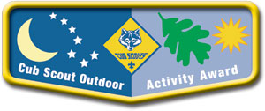
Cub Scouts at all levels from Tiger to Webelos can earn the Outdoor Activity Award. When the award is first earned, the scout receives the pocket flap award, worn on the right pocket flap of his uniform. In each additional year that he earns the award, a wolf track pin is attached to the flap. The Summertime Pack Award pin should be pinned through this patch just like the wolf track pins.
Successive years should build on skills and experiences from earlier years, having the scouts participate in more extensive activities.
Requirements:
Scouts at all ranks must attend Cub Scout day camp or Cub Scout/Webelos Scout resident camp in the current program year.
Tiger Cubs
Complete one requirement in Achievement 5, 'Let's Go Outdoors' (Tiger Cub Handbook) and complete three of the outdoor activities listed below.
Wolf Cub Scouts
Assemble the 'Six Essentials for Going Outdoors' (Wolf Handbook, Elective 23b) and discuss their purpose, and complete four of the outdoor activities listed below.
Bear Cub Scouts
Earn the Cub Scout Leave No Trace Award (Bear Handbook, Elective 25h) and complete five of the outdoor activities listed below.
Webelos Scouts
Earn the Outdoorsman Activity Badge (Webelos Handbook) and complete six of the outdoor activities listed below.
Outdoor Activities:
With your den, pack, or family:
- Participate in a nature hike in your local area. This can be on an organized, marked trail, or just a hike to observe nature in your area.
- Participate in an outdoor activity such as a picnic or park fun day.
- Explain the buddy system and tell what to do if lost. Explain the importance of cooperation.
- Attend a pack overnighter. Be responsible by being prepared for the event.
- Complete an outdoor service project in your community.
- Complete a nature/conservation project in your area. This project should involve improving, beautifying, or supporting natural habitats. Discuss how this project helped you to respect nature.
- Earn the Summertime Pack Award.
- Participate in a nature observation activity. Describe or illustrate and display your observations at a den or pack meeting.
- Participate in an outdoor aquatic activity. This can be an organized swim meet or just a den or pack swim.
- Participate in an outdoor campfire program. Perform in a skit, sing a song, or take part in a ceremony.
- Participate in an outdoor sporting event.
- Participate in an outdoor Scout's Own or other worship service.
- Explore a local city, county, state, or national park. Discuss with your den how a good citizen obeys the park rules.

